Target is a national clothing, homewares and general merchandise retailer with over 280 bricks and mortar stores across Australia (Wesfarmers, 2019). Target’s online presence (<https://www.target.com.au/>) draws heavily on the layout of these physical stores, a technique that Morville and Rosenfeld (2007, p. 92) describe as “metaphor”. This, they argue, allows users to intuitively understand the content and function of an online store because it is roughly equivalent to a typical physical store (Morville & Rosenfeld, 2007, p. 92). In both cases, for example, merchandise is categorised into departments such as “Women”, “Kids”, “Toys” and “Entertainment”. These taxonomies, are a central plank of the Information Architecture (IA) of a well-designed website (Bigby, 2016; Morville & Rosenfeld, 2007, p. 95). Navigation, on the other hand, is the assortment of components that form the user interface, allowing users to find information and (hopefully) perform an action such buying a product (Bigby, 2016). The relationship between IA and navigation is symbiotic. While Morville and Rosenfeld (2007) generally argue for the primacy of IA over navigation, Bigby (2016) posits a more harmonious association, where IA and navigation necessarily inform the design of the other during the development process.

Kalbach (2007) describes three primary categories of navigation: structural, associative and utility. Morville and Rosenfeld (2007, p. 144), on the other hand, suggest a slightly different but related taxonomy: global, local and embedded. For the purposes of analysing the Target website, I will use the system proposed by Kalbach (2007).

1. Structural navigation allows users to move either up or down the website’s hierarchy. Structural navigation has two subdivisions: main or global navigation and local navigation.
   1. Main navigation leads users to pages within the site and is styled and designed to behave in a reliable way. Main navigation, therefore, generally remains unchanged in a consistent position on just about every page of a site (the exceptions will be discussed later). Main navigation is designed to answer important questions for the user such as “does this site contain the information I am looking for?”. It allows users to easily switch topics (or in the case of Target) departments, reminds users of their location within the site if they are interrupted and generally defines the scope of the website as a whole. In this case and more generally, there is a strong correlation between main navigation and how the site content is organised. An example of main navigation is provided below:
   2. An extension of main navigation, local navigation is used to access lower levels in the structure with a selected category. Local navigation provides context to the main navigation categories and gives the first indication of the granularity of the site as a whole. In this case, there is a strong correlation between main navigation and how the site content is organised. An example of local navigation is provided below:

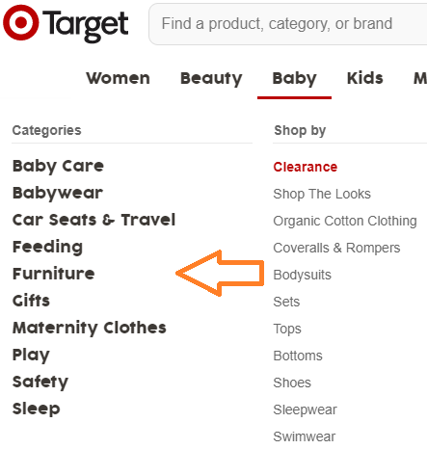

1. Associative navigation makes connections across levels of the site hierarchy. The four types types of associative navigation are contextual, adaptive, quick links and footer navigation.
   1. Contextual navigation is situational and can link to similar pages at the same level, new content areas or a new site altogether. Target is controlled by the Wesfarmers Group (Wesfarmers, 2019) which also owns Catch Group Holdings, an online shopping and customised delivery platform. There is a weak if any correlation between this form of navigation and how the Target site is organised. A contextual link to catch.com.au which appears below the main navigation of the Target site is shown below:
   2. 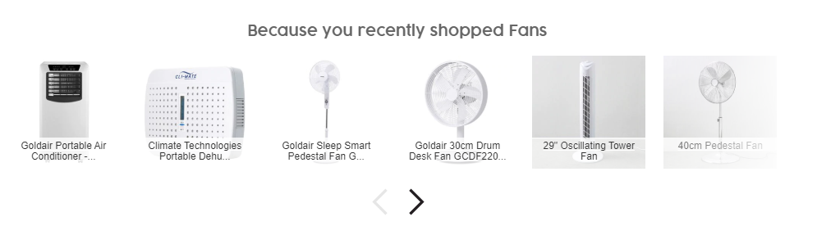Adaptive navigation is a special form of contextual navigation where links are generated according to user behaviour or seller priorities. In the case of the Target website, users will be presented with recommendations based on their current search criteria or position in the site hierarchy. There is a moderate correlation between this navigation feature and the organisation of the site. An example of adaptive navigation is shown below:
   3. Quick links provide access to important areas of the site that may not be represented in the main navigation. A marketing site such as Target will use quick links to promote products or make finding seasonal goods (e.g. Back-to-School, Christmas) easier. There is a moderate correlation between this navigation feature and the organisation of the site. An example of quick links navigation is 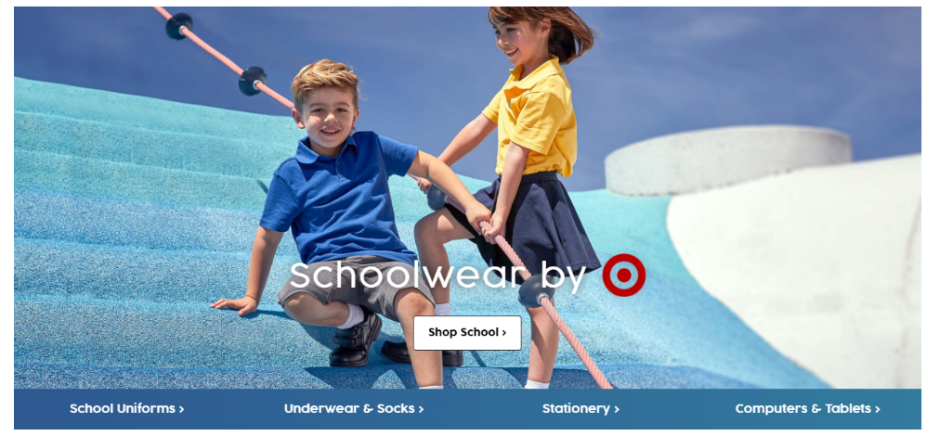shown below:
   4. Footer navigation contains information that supplements the content of the site. Usually represented by text links, footer navigation often accesses a single page displaying terms and conditions, copyright information and a site map. Footer navigation does not directly address a user need but is nonetheless important in the organisation of the site. The site map is perfectly correlated to the organisation of the site as a whole. The footer navigation of the Target site is shown below:



1. Utility navigation connect to tools and features that are needed to achieve the aims of the site. In the case of the Target site, these tools include shopping carts and payment options. These sites rarely contain main navigation so as to not distract the user from the task. There is a weak correlation between how the content of the site is organised and the utility in question. An example of a utility is shown below:

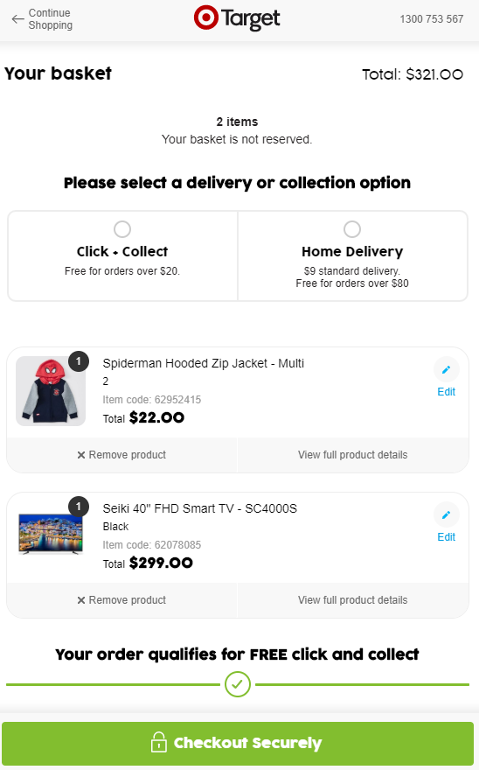

**References**

Bigby, G. (2016). What is the Difference Between Navigation & Information Architecture (IA)? Retrieved from <https://dynomapper.com/blog/19-ux/177-navigation-vs-information-architecture-ia>

Kalbach, J. (2007). *Designing web navigation*. Sebastopol, CA: O'Reilly Media, Inc.

Morville, P., & Rosenfeld, L. (2007). *Information Architecture for the World Wide Web* (3rd ed.). Sebastopol, CA: O'Reilly Media, Inc.

Wesfarmers. (2019). *2019 Wesfarmers Annual Report*. Retrieved from <https://sitefinity.wesfarmers.com.au/docs/default-source/reports/wesfarmers-2019-annual-report.pdf?sfvrsn=2>